Data Bases assignment 2
N1
- Candidate key – when an entity has more than one keys these keys are candidate ones because any of them can become primary keys.
- Primary key – a unique identifier that is minimal not null.
- Foreign key – this key establishes a link between two tables by referencing the primary key of another table. values in the foreign key column must exist in the referenced table's primary key column or be NULL.
- Composite key – this is a PKs combined.
- Natural key – a unique identifier that already exists in the real world like Social Security Number.
- Surrogate key – artificially created key.
N2
- Because Room is a weak entity when mapping we use a composite key because a room cannot exist without a building. Pk {[buildingID: int; roomID: int; ]}.
- Employee = {[ employeeID:int; departmentID: int; ]} - because this is just normal binary 1:N relationship demartment’s pk becomes FK in order to merge this to entities.

N3
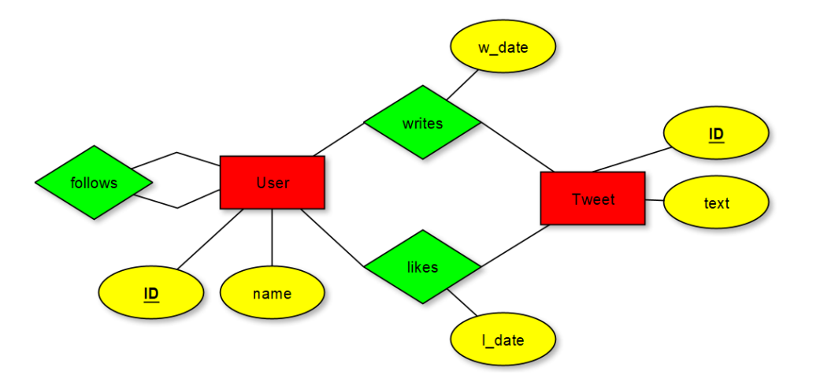
User = {[ userID: int; name: string]}
Follows = {[ FollowerID: int; FollowedByID: int; ]}
Tweet = {[ tweetID: int; text:string; UserID: int; w_date: date ]}
Likes = {[ UserID:int; TweetID:int; l_date:date]}
N4
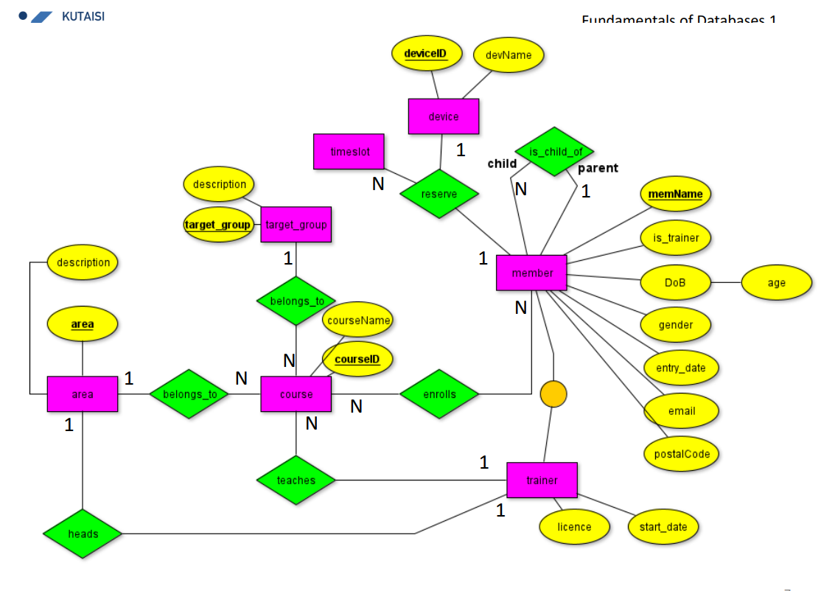
Member = {[memName:string; is_trainer:boolean; DoB:date; age:int; gender:string; entry_date:date; email:string; postCode:int; is_child_of:string]}
Trainer = {[memName:string; license:boolean; start_date:date ]}
Course = {[ CourseID:int; courseName:string; TargetGroup:String; area:String; trainerName:string ]}
Area = {[ area:string; description:string; trainerName:string ]}
targetGroup = {[ target_Group:String; description:String]}
Device = {[deviceID:int; devName:String]}
Reservation = {[ memName:String; deviceID:int; timeslot:date]} - >
Constraint {[memName:string; timeslot:date]} ( the other candidate key)
Enrollment = {[ courseID:int; memName:string]}
6. Vertical partitioning is preferable, because the table is split by columns and different sets of attributes (columns) of the same entity are stored in different tables.
7. in all-in-one relations there are a lot of NULL values, constraints and lacks flexibility which makes it harder to update the data.
N4
- Queries often refer to common attributes. - I’d choose vertical mapping here because , because we need just common attributes which are attributes of the one row which comes from supertype.
- Queries usually addres both, the common and the specific attributes of a subtype. - horizontal, because we need both common and specific attributes.
- Generalization gets constantly a lot of insert operations. – horizontal, because it means that we can add other instances of entities, which are subtypes themselves of the supertype and the attributes will be the same as the subtype.

What is – to your mind - more challenging in regard to the PK: Duplicating the PKs from the supertype to the subtypes or enforcing uniqueness of the PKs over the subtype relations? Which scenario belongs to which mapping?
Duplicating the PKs from the supertype to the subtypes – vertical mapping enforcing uniqueness of the PKs over the subtype relations – horizontal mapping second scenario is more challenging because we just overview every relation in order to identify PK and indicate it into other instance and its more easy to use vertical mapping to identify the PK of supertype which is foreign key for the subtypes.
N5
